Question 1 Answer all parts:
1a) Name 2 lines of evidence to recognize subaerial exposure in carbonate sediments. (6 marks)
1b) Explain the physical, chemical and/or biological processes for one of these. (6 marks)

Question 2:
Explain briefly how corals on a modern reef respond to changes in intensity of light and energy as water depth increases. (8 marks)

Question 3. Answer all parts:
You are provided below with paired global palaeogeographic and climate maps from http://www.scotese.com (Figures 1a, b). Use the map pair to answer the following questions specifically for the Devonian epoch:

a) Using an annotated diagram, illustrate the distribution of carbonate facies you’d expect on a Devonian carbonate platform you might observe in southern and central Europe. Include lithologies, grain types and sedimentary structures. (20 marks)

b) State one difference and one similarity between the diagram from (3a) and a diagram you would draw for a modern carbonate platform (e.g. in the Caribbean). (10 marks)

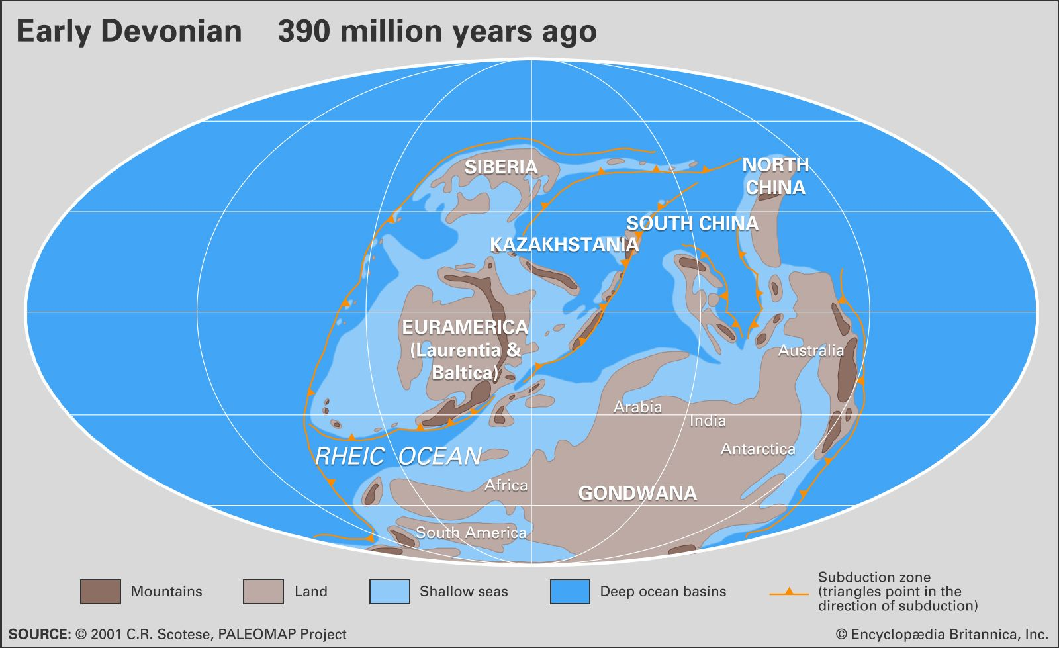
Figure 1a

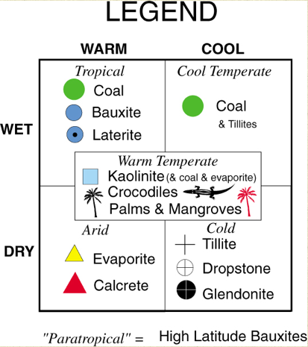
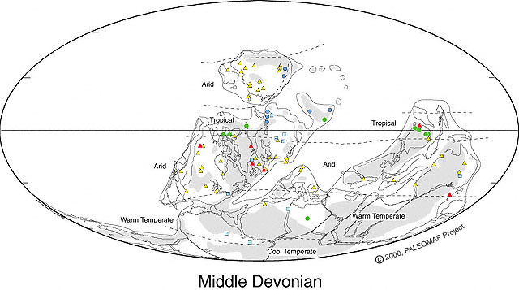
Figure 1b

Question 4. Answer all parts.
4a) Define and describe deep-marine clastic environments; you may use diagrams in your answer and use named examples where you can (25 marks)
4b) Name and describe the modes of sediment transport in deep-marine clastic environments, and the events that may trigger them; you may use diagrams in your answer and use named examples where you can (25 marks)

